**LAB 1**

**COMMENTS:**

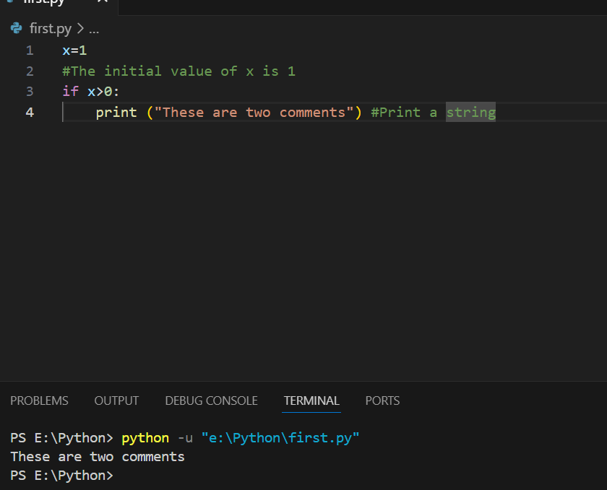

**INPUT:**

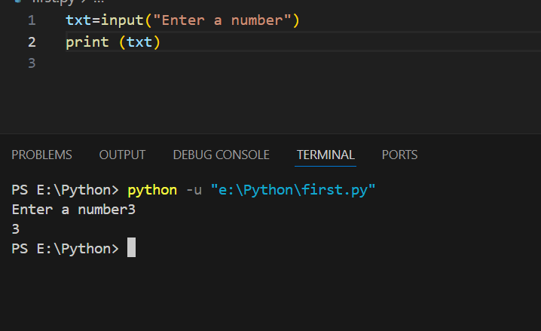

**MUTIPLE STATEMENT ON A SINGLE LINE**

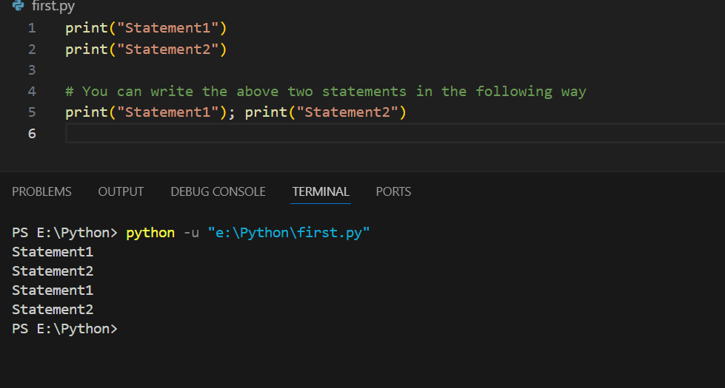

**SPACE INDENTATION:**

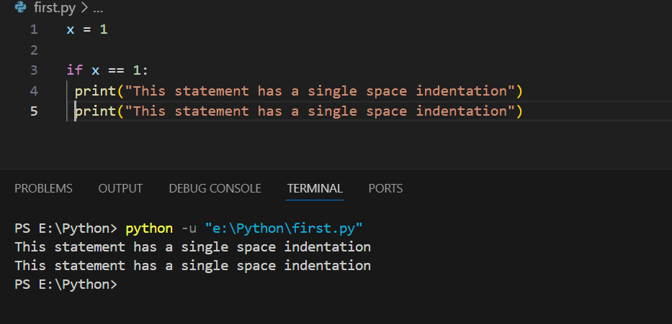

**TAB INDENTATION**

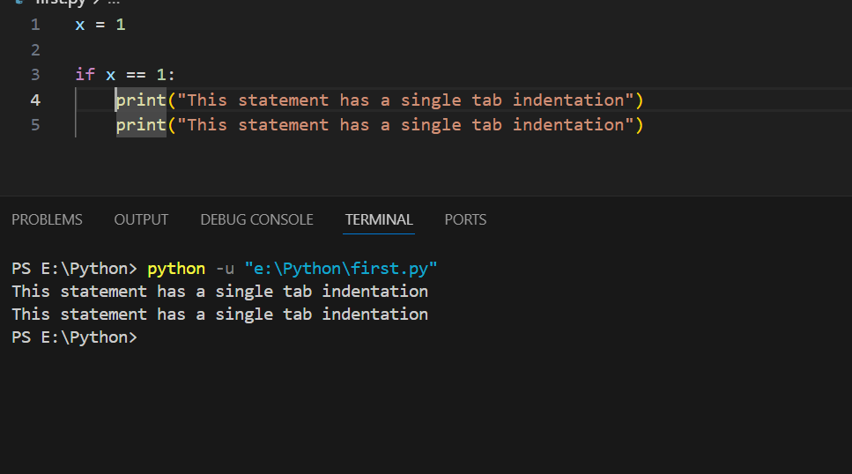

**SPACE AND TAB INDENTATION**

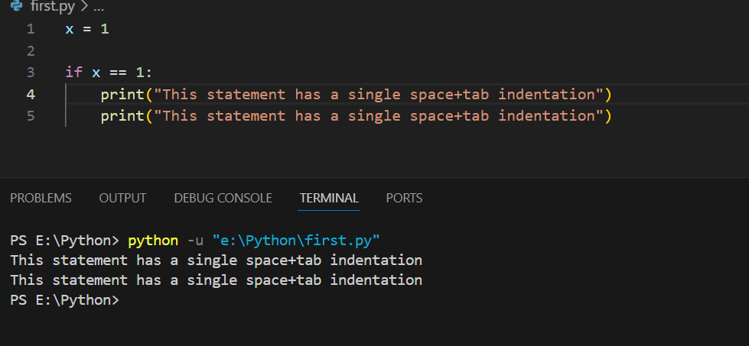

**NUMBER**

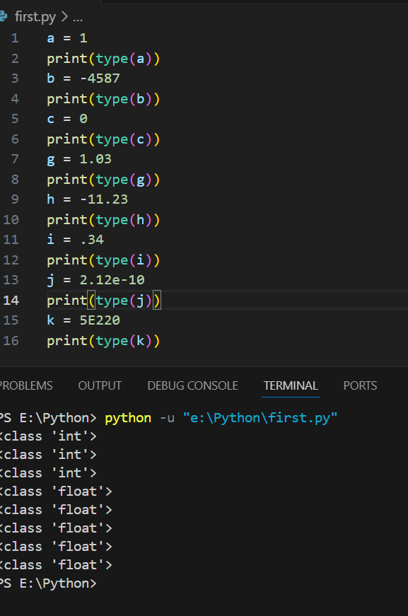

**COMPLEX NUMBER**

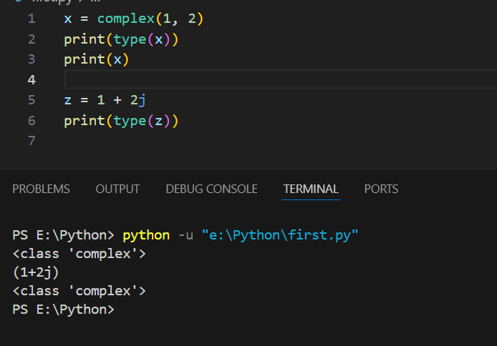

**BOOLEAN**

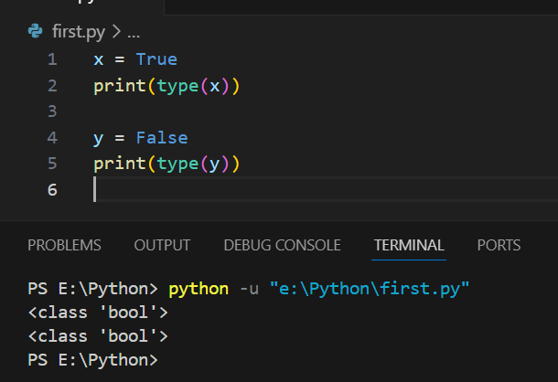

**STRINGS**

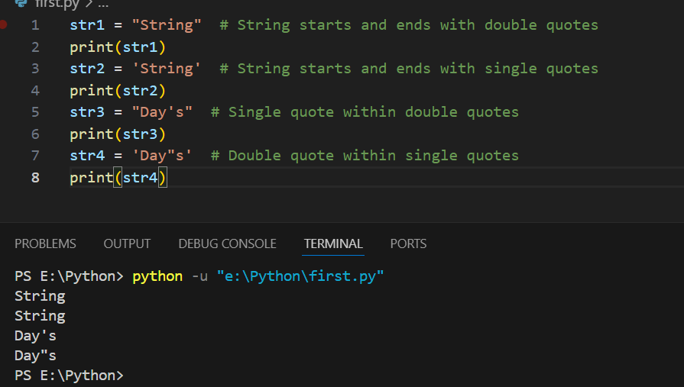

**SPECIAL CHARACTERS IN STRINGS**

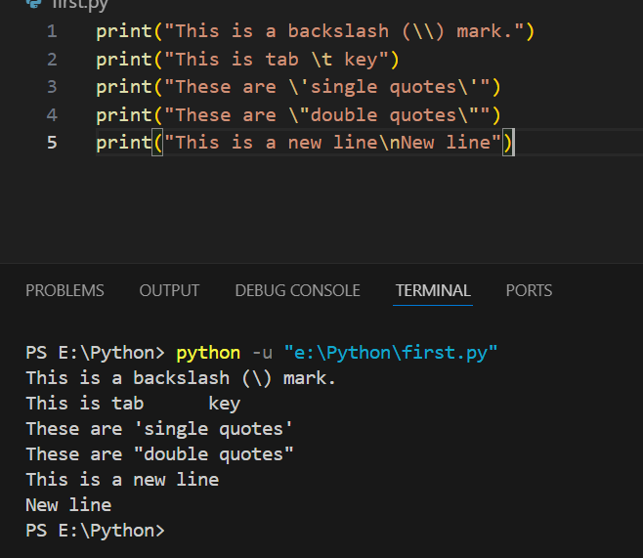

**STRING INDICES**

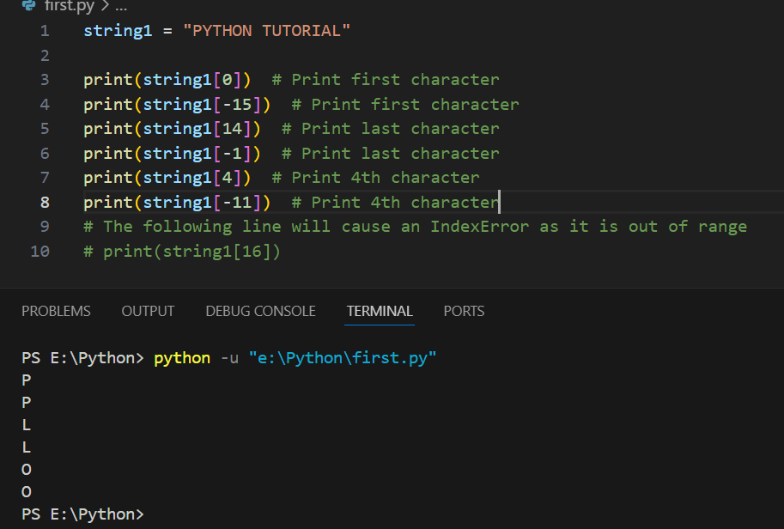

**CREATING LIST**

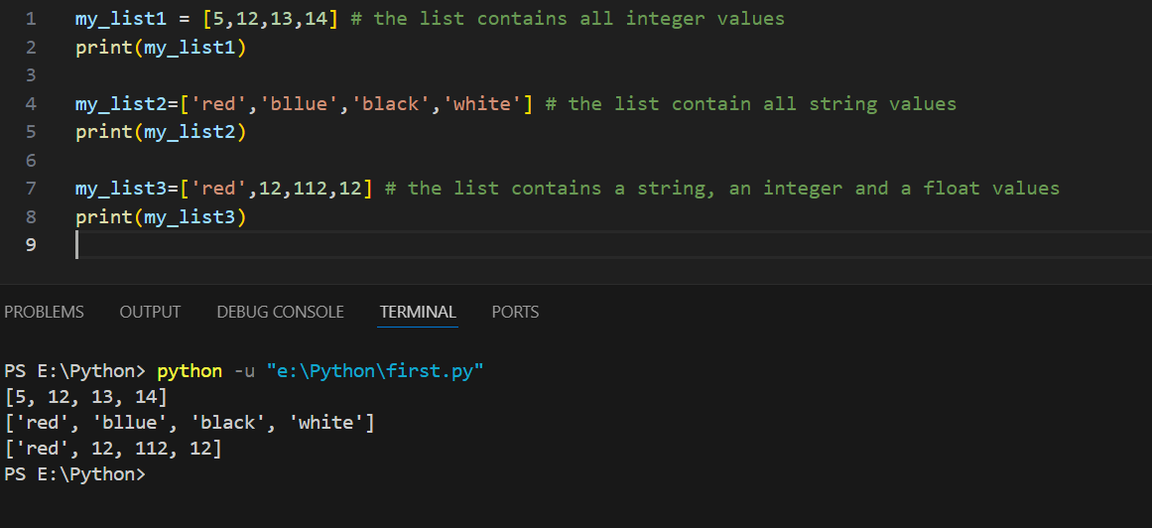

**LIST INDICES**

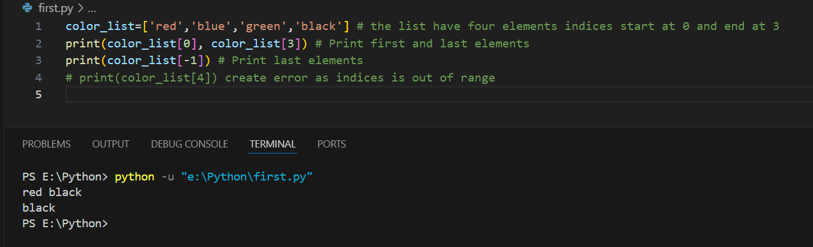

**LIST SLICE**

